**DESCRIBING HOME AND WORK/ STUDY ROUTINES**

**Esta clase está orientada a practicar el presente simple en todas sus formas y a lograr que ustedes produzcan un texto escrito oral en el que hablen de ustedes mismos.**

**Para eso, primero vamos a practicar responder preguntas en base a un texto, corregir oraciones usando la forma negativa y finalmente, trabajando con un texto que les servirá de modelo para que luego preparen su propio texto sobre ustedes mismos.**

1. **Read and answer the questions about Amina’s day.**

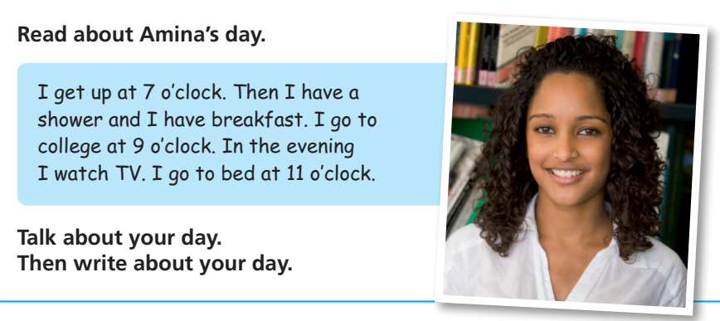

1. What time does she get up?
2. Does she have breakfast?
3. Is she a student?
4. What does she do at 9 o’clock?
5. What does she do in the evening?

**1. Read about Sylvia and her team and correct the sentences using the negative form. [1]**

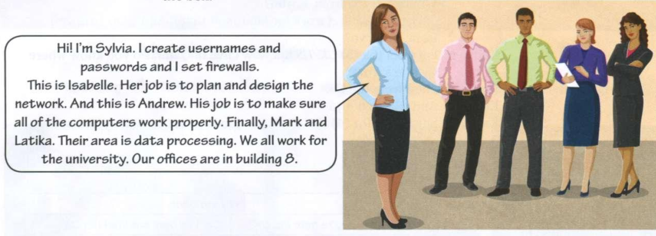

Hi! I’m Sylvia. I **create** usernames and passwords and I **set** firewalls.

This is Isabelle. She **plans** and **designs** the network. And this is Andrew. He **makes sure** all the computers **work** properly. Finally, Mark and Latika. They work in the data processing area. We all **work** for the university. Our offices **are** in building 8.

**EXAMPLE:**

*Sylvia works in the data processing area.*

*She doesn’t work in the data processing area.*

1. Sylvia and her team work in building 6.
2. Andrew sets firewalls.
3. Mark and Latika plan and design the network.
4. Isabelle makes sure all the computers work properly.
5. They work for Dell.

**Ahora sí llegamos a nuestro modelo de texto. La idea es ir estudiándolo paso a paso, desde el vocabulario hasta la secuenciación de eventos, para que después ustedes hagan su propio texto.**

**Marco’s daily routine.**

**Before you read, pay attention to the following linking words[2]:**

And:

After:

Because:

But:

Or:

Then:

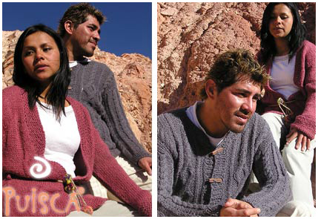I’m Marcos Luna. I’m 21 a**nd** I live and study in San Salvador de Jujuy. I live in a small house with my parents **and** my two sisters. I study programming in our local university. On week days, I usually get up at 7 o’clock. **Then** I have a shower and I have breakfast. I go to university by bus **because** it’s three kilometers from my house.[3] I often[4] have lunch at university **because** I have classes in the morning **and** in the afternoon. **After** class, I go home **and** I play computer games **or** play the guitar **and** study for a couple of hours. At weekends I play rugby **but** I don’t go out go out much **because** I’m always tired after the game.

**What does Marco do at these times? Put his activities under the correct headings**

|  |  |  |  |
| --- | --- | --- | --- |
| **In the morning** | **In the afternoon** | **In the evening** | **At weekends** |
| **gets up at 7 o’clock** |  |  |  |

**Put Marco’s activities in the correct sequence.**

1. I go home.
2. I have breakfast.
3. I go to university by bus.
4. I usually get up at 7.00.
5. I have lunch at university.
6. I have a shower.
7. I study for a couple of hours.

**Now answer the following questions about Marco. Be careful with questions with the verb “be” and questions with other verbs.**

1. What’s his name?
2. How old is he?
3. Where does he live and study?
4. Does he live in a flat?
5. Who does he live **with**?
6. Why does he take the bus to university?
7. When does he have classes?
8. Where does he have lunch?
9. What does he do after class?
10. What sport does he play?
11. Why doesn’t he go out much?

**Now, write about your daily routine. Use the text about Marco and the questions as a guide.**

1. Este texto no describe rutinas diarias, pero se refiere a la tarea habitual de cada uno de los miembros del equipo, por eso lo estamos usando para repasar las formas negativas.
2. Linking words: conectores
3. Voy a la universidad en colectivo porque está a tres km de mi casa. Otras opciones: I go to university by car because…(voy en auto porque) / I cycle to university because… (voy en bicicleta porque…) / I walk to university because it is not far from my house (camino porque no está lejos de m casa)
4. Often: a menudo (siempre se ubica entre el sujeto y el verbo)